NETFLIX DATA ANALYSIS
KPI’S
- Total KPI
How big is our content library?


- Movies VS TV Shows
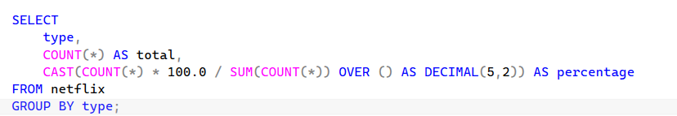

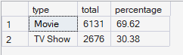

- Content growth KPI (Latest Year)
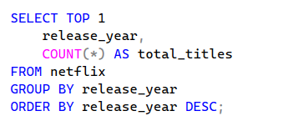



- Top Genre KPI

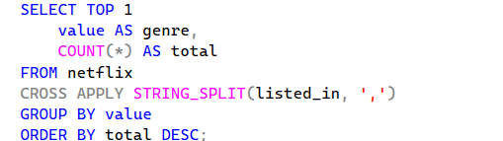



Business Questions
- How has content grown over time?


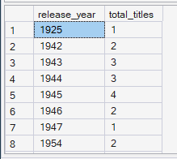

- What are the most popular genres?


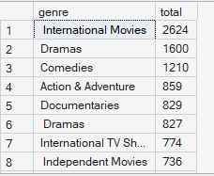

- Which countries produce the most content?


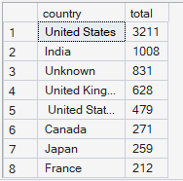

- Is content growth increasing or slowing?


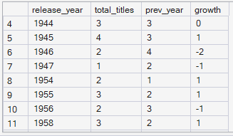

- What type of audience is targeted?
